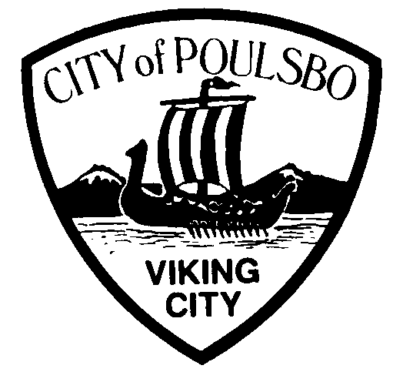
Poulsbo Police Department
Honor * Integrity * Teamwork * Professionalism

Ron Harding, Chief of Police
2022 Biased-based Policing Analysis
The most frequent way police agencies have attempted to learn whether bias-based policing is systematically occurring is through the analysis of discretionary traffic stops and enforcement. The Poulsbo Police Department tracks infractions through the electronic capture of SECTOR (Statewide Electronic Collision and Ticket Online Records) Ticketing data. The infractions contain discoverable demographic information.
I have reviewed the Criminal Traffic and Traffic Infraction citations in the table below. I have found no indication of racial profiling or bias based on these statistics. Poulsbo Police officers issued 8.1% more citations (both criminal and traffic) in 2022 than they did in 2021. This slight increase was due to loosening restrictions placed on operational parameters to reduce the spread of the COVID Virus, but an uptick in calls for service, reducing the time available to enforce traffic laws.
If the officer could not distinguish the race/ethnicity of the individual, the designation of unknown was placed in the race box. Demographic statistics for the City of Poulsbo are listed at the end of the table.

 | Traffic Infraction² |  | Criminal Traffic³ |  | Totals⁴
Race or Ethnicity | # by race | % by race | # by race | % by race | # by race | % by race | Poulsbo Demographics¹ | Kitsap County Demographics¹
Caucasian - alone | 120 | 67.4% | 16 | 76.1% | 136 | 68.3% | 85.4% | 76.0%
African American | 3 | 1.6% | 0 | 0% | 3 | 1.5% | 1.12% | 3.2%
American Indian or Alaskan Native | 5 | 2.8% | 1 | 4.7% | 6 | 3.0% | 0% | 1.7%
Asian or Pacific Islander | 12 | 6.7% | 0 | 0% | 12 | 6.0% | 4.0% | 6.4%
Hispanic | 8 | 4.4% | 0 | 0% | 8 | 4.0% | 10.4% | 8.2%
Unknown/Other | 30 | 16.8% | 4 | 19.0% | 34 | 17.0% | 4.3% | 4.5%
TOTAL | 178 |  | 21 |  | 199

ANALYSIS
The Poulsbo Police Department prohibits race, ethnicity, nationality, sex, sexual orientation, economic status, age, cultural group, disability, or affiliation with any other identifiable group from being used as the basis for providing different levels of law enforcement service or the enforcement of the law.
In 2022, all Poulsbo Police Department employees participated in training that included:

- Anti-Bias-Based Policing
- Ethics in Law Enforcement
- Hate Crimes Training for Law Enforcement
- Implicit Bias Training
In addition to examining discretionary stop data, the Poulsbo Police Department also tracks and investigates all citizen complaints of bias and racial profiling. In 2022, no citizen complaints alleged racial discrimination or profiling.
The Poulsbo Police Department also tracks and investigates uses of force by ethnicity and gender. In 2022, there were twenty one use of force incidents. Sixteen involved Caucasian suspects and sixteen were male suspects. Three female suspects and 4 persons of unknown ethnicity were subjected to the use of force. None of the incidents involved any other ethnicity.

Use of Force by Ethnicity
Caucasian | 17
African American | 0
American Indian or Alaskan Native | 0
Asian | 0
Hispanic | 0
Unknown/Other | 4
Total | 21

Use of Force by Gender
Male | 16
Female | 4
Unknown | 1

CONCLUSION
In my review, I have found no evidence of bias-based policing in the Poulsbo Police Department. The demographics of the city/county, the listed statistical data, and the lack of specific complaints support this conclusion.
I recommend the Poulsbo Police Department maintain its current course of providing annual training to all employees regarding bias-based policing and other similar practices that promote fairness, ethics, racial equity, and awareness in their interactions with all community members.

Ron Harding
Chief of Police

